**PROJECT PROPOSAL**

**Company : *NovoFM***

**Members : Badis, Håkon, Charlie, Arshad ;**

**Smart Goal:**

Our goal is to investigate applications to help operating and monitoring the facilities, in efficient way, using embedded systems by May 2016.

**Set of Objectives:**

* Research the state of the art of facility management
* Idenification of service potential
* Evaluation of service ideas
* Develop the system
* Validating and integrating the system
* Documenting all the steps and creating a technical manual

**What we want to do?**

Use a protocol of communication, and develop a website and a phone application to show information collected from sensors to allow the user to regulate the environment.

**Work Breakdown Structure:** 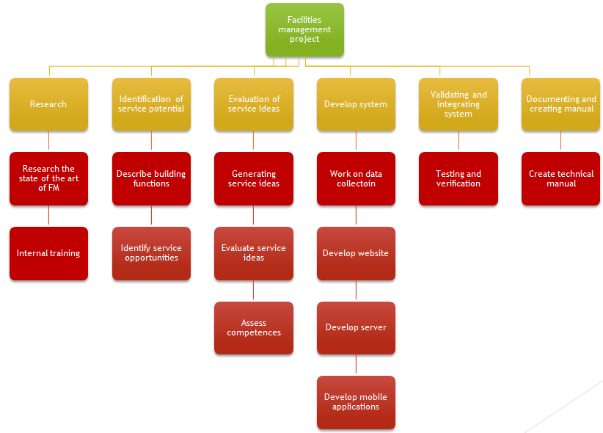

**Risk Management:**

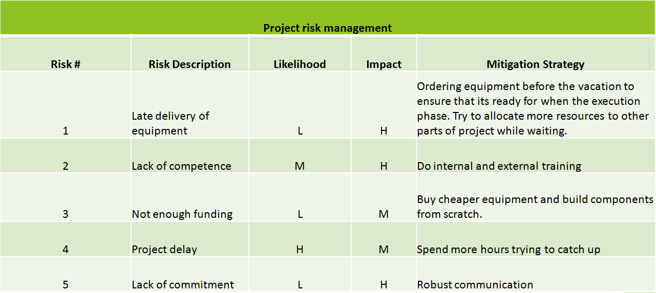

**You can find Gantt and Pert/CPM diagrams in the attached files.**